IGP TAP Transmission Subgroup
Feedback on REZ Study
10/xx/2021
This feedback to HECO is based on HECO’s slides and presentation on their initial REZ Study on 10/1/2021.
TAP members attending: Andy Hoke (NREL, Chair), Dana Cabbell (SCE), Matt Richwine (Telos/HNEI), Deepak Ramasubramanian (EPRI). Not able to attend: Debbie Lew (ESIG)
HECO presenters: Ken Arakawa, Li Yu, Addison Li, Marc Asano, Chris Lau

TAP feedback and comments are divided into three categories:
- Informational – no action needed.
- Suggest revising REZ study before November 1 submission deadline.
- Consider feedback for future portions of the IGP process (after the Nov 1 deadline).

TAP comments during meeting and HECO responses
Do the REZ zones consider environmental and community acceptance constraints?
- Response: Not at this stage. They are based on the NREL Alt 1 study with relaxed land slope constraints. A next step will obtain stakeholder feedback. We expect significant feedback from stakeholders, especially in certain potential REZ zones.
The REZ study examines a single point in time (evening peak). Is this because it is assumed to be the worst-case from transmission capacity perspective?
- Response: Yes.
- TAP follow up: Is this based on the assumption that future resources will include a BESS?
- Response: Yes, or that the resources will otherwise be made dispatchable.
What transmission constraints were considered? Thermal? Voltage?
- Response: Thermal (overcurrent) constraints are considered. Voltage constraints would be considered in a future more detailed study after receiving stakeholder input.
Were N-1 and N-1-1 contingencies considered in the REZ study power flows?
- Response: N-2 was considered for Oahu, and N-1 was considered for Maui and Hawaii. N-2 and N-1 scenarios were limited in scope for the study.
- TAP follow up: Future work could look at which contingencies drive needs for transmission upgrades in detail.
Why do you differentiate between “REZ enablement” and “Transmission network upgrades” separately rather than just considering the total transmission investment needed?
- Response: REZ enablement can be directly assigned to a project, whereas transmission upgrades may not be able to be. Also, see study results, where many REZ groups can be interconnected with only REZ enablement (i.e. a transmission intertie, and without network upgrades). We think this is a key finding.
How were the dispatches chosen? (For example, the dispatches in the screenshot below)
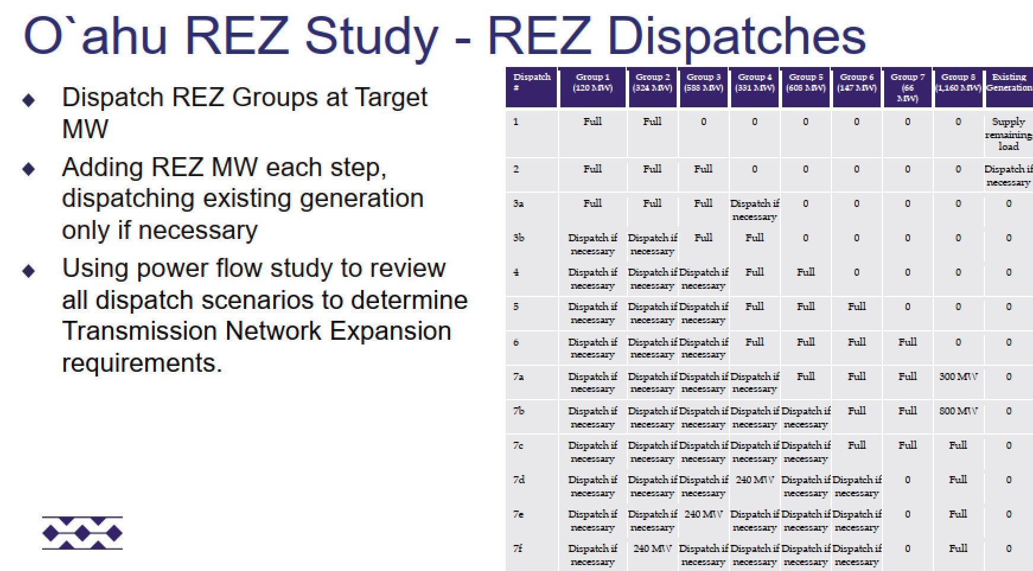
- Response: We chose a range of dispatches designed to push each REZ zone to peak output.
- TAP follow up: The dispatches chosen are very important to the study outcome. Dispatches that draw from multiple REZ zones in parallel may produce a lower need for transmission.
- Response: Agreed. See the study outcomes. For Oahu, network upgrades are only needed for one REZ group (Group 8), and only beyond 300 MW. Beyond that threshold, Group 8 appears likely to be unfeasible. We will add a note about the 300 MW threshold to the slides. This REZ group is one of the most likely to see stakeholder pushback due to its location.
- TAP follow up: Agreed that this is an important finding. It can be important to consider not only active power redispatch but also reactive power dispatch and voltage profile across the network. This can determine network hosting capacity limits when considering multiple REZs at the same time.
- TAP follow up: The matrix on slide 17 is critical. Given the ~3x overbuild by nameplate of renewables, there should never be any case where any zone is at full export; it would be a very unusual and avoidable operating condition to have only one zone able to export and all other zones not able to. By all zones exporting and sharing the power generation, you’re also distributing the power flows across the transmission infrastructure and reducing the chance of overloads. By considering any zone maxed out, it creates a local stress on the infrastructure and drives up the need for more infrastructure when in reality, the system may not need to be operated that way. Therefore, more dispatch conditions need to be evaluated where all zones are sharing the effort. Then when overloads are determined, shift more export to zones that do not as quickly overload the transmission system. This is very time-consuming to do manually; a chronological tool like PLEXOS with a nodal transmission model will greatly expedite such an analysis.
HECO should consider a chronological tool with an underlying transmission topology rather than a single point in time for this REZ analysis. For example, you need to make sure you have enough energy to charge the BESS. Also consider stacked BESS services. There are chronological tools that enable this, including iteration. It can be very hard to tell if you’re close to a thermal constraint using manual dispatches since the constraints are binary.
- Response: For this initial analysis, the goal is to obtain approximate $/MW transmission costs for different REZ zones to inform the RESOLVE study. That would then be followed by PLEXOS, which is chronological. There will be future iterations that go into greater detail. We also need the basic REZ costs to get stakeholder input on potential REZ/PV locations. The process will be iterative.
- TAP follow up: The approach of ranking groups is a good one. However, the per-unitized cost estimate (screenshot below) misses the very important fact that the cost of transmission infrastructure does not vary linearly with the MW of REN integration; it varies in discrete steps (see hand sketch below). Linearizing it can result in a misleading metric that then feeds into the beginning of the RESOLVE-PLEXOS process shown on slide 57 and affects all downstream results. An evaluation of more MW integration levels is strongly recommended for Group 8, and recommended for the other groups as it may determine a different priority/cost for integration in each zone; for example, a stepwise $/MW curve for each group may be obtained, as sketched below. At the same time, the TAP recognizes that this is an initial pass at transmission cost estimation that will be refined in future steps.

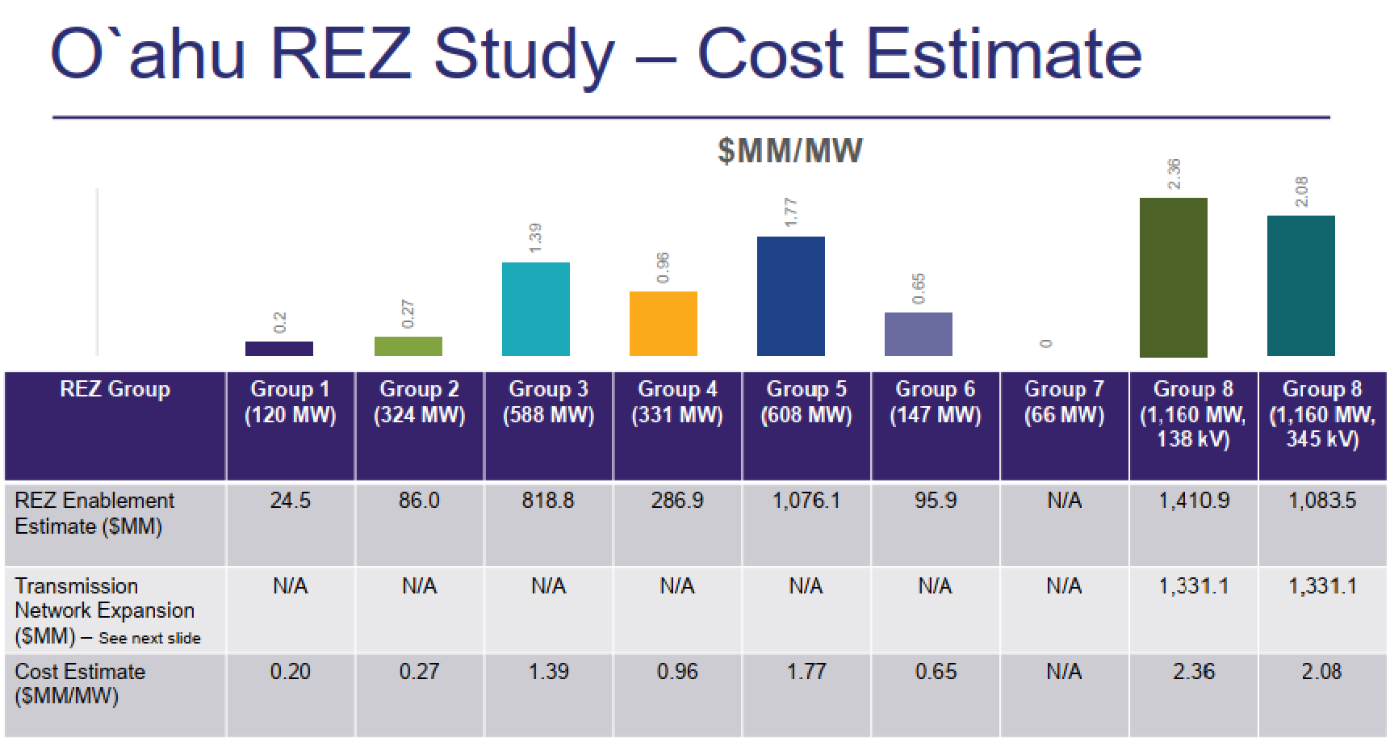
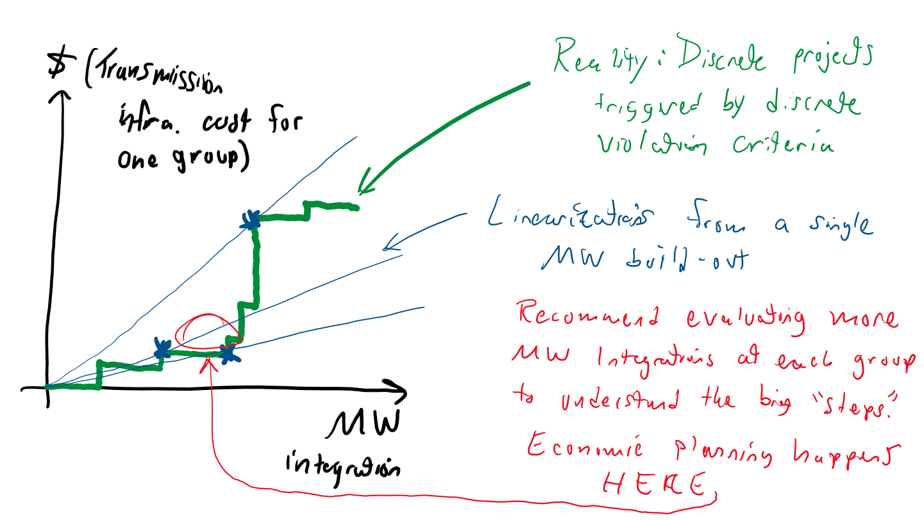

When will non-transmission alternatives be considered?
- Response: This would be considered in a more detailed analysis later in the process.
- TAP follow up: Non-transmission alternatives such as power flow control devices (phase shifters, in-line compensators, etc) or even energy storage elements for congestion management can help with improving power flow across the network. Use of dynamic line rating technology to manage flows in operational time frame can also be considered.
Why was offshore wind studied only for Oahu? Perhaps because there is sufficient PV resource on other islands?
- Response: This was based on an NREL study that looked at Oahu.
Why is the Kahe offshore wind location not feasible?
- Response: It is not feasible with the 138 kV option, but it is feasible with the 345 kV loop. We will clarify this.
The 345 kV would be a new transmission voltage level for HECO meaning a need for a whole new class of equipment, spare parts, etc.
- Response: Agreed. The 345 kV option is only slightly cheaper than the other options, and that does not consider the costs of adding equipment for a new voltage class, so we do not think it will be the best option.
- TAP follow up: 345 kV would also come with additional land costs if your existing substations don’t have room.
Does adding 138 kV make sense for Maui? Perhaps this is subject to the same considerations as 345 kV on Maui, since it would be a new voltage level for that island?
Does the eventual PLEXOS study feedback into another iteration of RESOLVE?
- Response: Yes, that is a later part of the IGP process not shown on the slide in question (screenshot at end of this document).
The TAP agrees with the premise that it is preferable to provide planned interconnection points for renewables rather than piecemeal tapping of transmission lines as is currently being done.
Overall, the REZ study does a good job of establishing transmission limits that may impact amounts of PV that can be interconnected beyond what is seen from the resource analysis. HECO should also consider environmental concerns and community feedback before finalizing REZ plans.
- Response: Agreed. A next step is to engage with the communities.
What is the motivation for the study and the resources the study aims to facilitate?
- Response: We are working towards 100% renewables. Existing resource additions are already getting curtailed at times. Putting in new transmission lines is expected to take 20+ years. The IGP analysis needs to account for those long-term transmission costs.

Other TAP comments post-meeting:
It appears the study did not include generation contribution from local DERs. Couldn’t BTM DERs with batteries serve a significant portion of evening load in the future, thereby reducing some transmission constraints?
- Response: The study did not include contributions from DER. The study was narrowly focused on allowing large blocks of grid-scale resources. RESOLVE would pick DER and/or grid-scale resources, and follow-on studies would be needed to determine what those specific transmission requirements would be.
The study noted that dispatches that source all the generation from one area should be avoided. That makes sense, but what about a severe weather scenario that makes generation one side of an island unavailable? Does that need to be considered?
- Response: Good point and we will need to think about this one more. This was not studied in the REZ study but may be needed as a future sensitivity as well as in separate studies. In developing severe weather scenarios, would also need to take into account the full suite of resilience-related solutions to manage the impact.
The following flowchart was shown at the end of the presentation (from a different slide deck, we think) showing how the REZ study would feed into future steps using RESOLVE then PLEXOS. Perhaps that flowchart can be added to the presentation to help give context.
